Ex. No. 1 | Design A Website Using HTML5
Date of Exercise | 16/07/2026
GitHub Host Link

Aim
To design and develop a simple yet structured HTML5-based website using various essential tags and features that demonstrate a clear understanding of semantic elements and formatting techniques.
Description
This exercise involves creating a basic website consisting of a single web page structured using HTML5.Students are expected to showcase proper usage of fundamental HTML tags and implement different types of content, including headings, images, tables, lists, hyperlinks, and comments. The webpage should visually represent the application theme (e.g., tourism, food delivery, hospital, personal blog) of the student, while effectively applying background and text colors for good design aesthetics.
Procedure:
- Based on the theme or concept for your web application (e.g.,
- Educational portal
Online Portfolio, etc.).
2. Create a new HTML5 file (index.html) in a text editor or IDE (e.g., VS Code,
Notepad). 3. Begin with the appropriate &lt;!DOCTYPE html&gt; declaration.
4. Use required semantic tags such as &lt;html&gt;, &lt;head&gt;, &lt;meta&gt;, &lt;title&gt;, and &lt;body&gt;.
5. Within the body:
o Insert a main heading using &lt;h1&gt; and section subheadings using &lt;h2&gt; or &lt;h3&gt;.
o Add multiple &lt;p&gt; tags to include relevant content.
o Use different hyperlinks:
▪ External link (with target=&quot;_blank&quot;)
▪ Internal link (to another section using id)
▪ Bookmark link
▪ Email link (mailto:)
▪ Phone link (tel:)
▪ Clickable image link
o Insert a descriptive image using &lt;img&gt;.
o Include a table with appropriate rows and columns.
o Insert:
▪ A description list using &lt;dl&gt;, &lt;dt&gt;, &lt;dd&gt;
▪ An ordered nested list using &lt;ol&gt; and &lt;li&gt;
▪ An unordered nested list using &lt;ul&gt; and &lt;li&gt;
o Add an HTML comment for each module or section.
o Use &lt;div&gt; for creating sections.
6. Apply a background color and change text color using inline or internal CSS.
7. Ensure code is clean, indented, and semantically correct.
8. Save the file and open it in a browser to verify output.

Program
<!DOCTYPE html>
<html lang="en">
<head>
<meta charset="UTF-8">
<meta name="viewport" content="width=device-width, initial-scale=1.0">
<title>The Rockstars Band</title>
<style>
*{
margin:0;
padding:0;
box-sizing:border-box;
font-family: Arial, sans-serif;
}

body{
background:#f4f4f4;
color:#333;
}

header{
background:#111;
color:white;
padding:20px;
text-align:center;
}

nav{
background:#222;
padding:10px;
text-align:center;
}

nav a{
color:white;
text-decoration:none;
margin:0 15px;
font-weight:bold;
}

nav a:hover{
color:gold;
}

.hero{
background:url('https://images.unsplash.com/photo-1501386761578-eac5c94b800a') center/cover;
height:400px;
display:flex;
justify-content:center;
align-items:center;
color:white;
text-align:center;
}

.hero h2{
background:rgba(0,0,0,0.6);
padding:15px;
border-radius:10px;
}

section{
padding:40px;
text-align:center;
}

.members{
display:flex;
justify-content:center;
gap:20px;
flex-wrap:wrap;
}

.card{
background:white;
width:250px;
padding:20px;
border-radius:10px;
box-shadow:0 0 10px rgba(0,0,0,0.2);
}

.card img{
width:100%;
border-radius:10px;
}

table{
width:80%;
margin:auto;
border-collapse:collapse;
}
table, th, td{
border:1px solid #333;
}
th, td{
padding:10px;
}

footer{
background:#111;
color:white;
text-align:center;
padding:15px;
}
</style>
</head>
<body>
<header>
<h1>The Rockstars Band</h1>
<p>Feel the Rhythm, Live the Music</p>
</header>
<nav>
<a href="#about">About</a>
<a href="#members">Members</a>
<a href="#tour">Tour Dates</a>
<a href="#contact">Contact</a>
</nav>
<div class="hero">
<h2>Welcome to Our Official Music Band Website</h2>
</div>

<section id="about">
<h2>About Us</h2>
<p>
The Rockstars Band is a talented group of musicians known for
energetic performances and unforgettable live shows. We blend
rock, pop, and indie music to create a unique experience for fans.
</p>
</section>
<section id="members">
<h2>Band Members</h2>
<div class="members">
<div class="card">
<img src="https://via.placeholder.com/250x200" alt="Singer">
<h3>Alex</h3>
<p>Lead Vocalist</p>
</div>
<div class="card">
<img src="https://via.placeholder.com/250x200" alt="Guitarist">
<h3>Ryan</h3>
<p>Lead Guitarist</p>
</div>

<div class="card">
<img src="https://via.placeholder.com/250x200" alt="Drummer">
<h3>Chris</h3>
<p>Drummer</p>
</div>
</div>
</section>
<section id="tour">
<h2>Upcoming Tour Dates</h2>
<table>
<tr>
<th>Date</th>
<th>City</th>
<th>Venue</th>
</tr>
<tr>
<td>15 Aug 2026</td>
<td>Chennai</td>
<td>Music Arena</td>
</tr>
<tr>
<td>22 Aug 2026</td>
<td>Coimbatore</td>
<td>Rock Stadium</td>
</tr>
<tr>
<td>05 Sep 2026</td>
<td>Bangalore</td>
<td>Live Concert Hall</td>
</tr>
</table>
</section>
<section id="contact">
<h2>Contact Us</h2>
<p>Email: therockstarsband@gmail.com</p>
<p>Phone: +91 98765 43210</p>
<form>
<input type="text" placeholder="Your Name" required><br><br>
<input type="email" placeholder="Your Email" required><br><br>
<textarea rows="5" cols="40" placeholder="Your Message"></textarea><br><br>
<button type="submit">Send Message</button>
</form>
</section>
<footer>
<p>&copy; 2026 The Rockstars Band | All Rights Reserved</p>
</footer>

</body>
</html>

Output
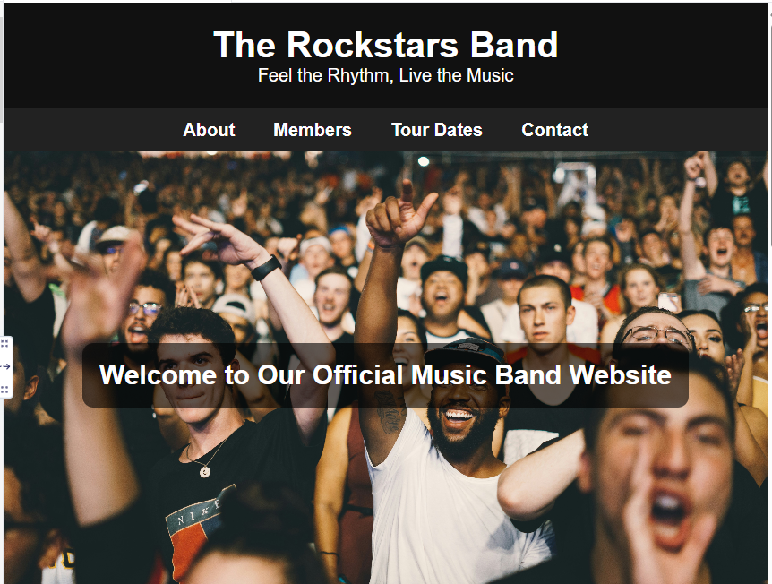

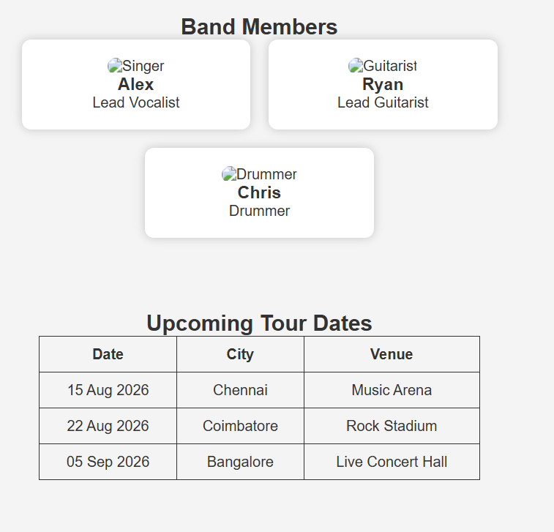

Result
The Startup Landing Page was successfully designed and developed using HTML5 with the required tags, links, lists, table, image, and formatting elements. The webpage executed successfully and displayed the expected output.

